**Bahria University, Lahore Campus**

Department of Computer Science

Lab Journal 10

**(Spring 2023)**

|  |  |  |
| --- | --- | --- |
| Course: | **Data Structures and Algorithm - Lab** | Date: _______________ |
| Course Code: | CSL-221 | Max Marks: 10 |
| Faculty’s Name: | Fatima Zulfiqar |  |

Name: _____________________ Enroll No: ___________________ Class: ______________

Objective(s):

Upon completion of this lab session, learners will be able to:

* Count number of leaf nodes in the binary tree
* Find height of the given tree
* Find the level of specific node in a binary tree
* Find nodes present in any specific level of a binary tree
* Find maximum depth of a binary tree

## Lab Tasks:

**Task 1**

Write a program to implement a given binary tree data structure

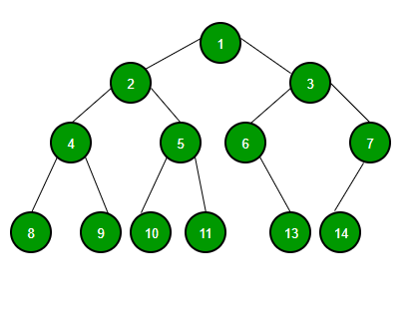

**Task 2**

Write a function to count and return total number of leaf nodes in a binary tree obtained in **Task 1.**

**Task 3**

Write an algorithm to find the maximum depth of a binary tree. Also write a formula to find maximum depth of a binary tree.

**Task 4**

Write an algorithm to find the height of a binary tree given in **Task 1**. Also write a formula to calculate height of a binary tree.

**Task 5**

Write an algorithm to find level of specific element present in a binary tree.

**Task 6**

Write an algorithm to display all the nodes present in any given level of a binary tree.

**Lab Grading Sheet :**

|  |  |  |  |
| --- | --- | --- | --- |
| **Task** | **Max Marks** | **Obtained Marks** | **Comments(*if any*)** |
| 1. | 0 |  |  |
| 2. | 2 |  |  |
| 3. | 2 |  |  |
| 4. | 2 |  |  |
| 5. | 2 |  |  |
| 6. | 2 |  |  |
| **Total** | **10** |  | **Signature** |

**Note : Attempt all tasks and get them checked by your Lab Instructor. Also for each task, attach a screenshot of the output.**